Service Level Agreements

Background

Increasingly, rewards and penalties are accruing to vendors in their ongoing relationships with their clients based on the level and responsiveness of the service being provided. Commonly referred to as Service Level Agreements, they frequently contain provisions similar to these:

- 95% of all priority 1 items must be resolved in the same business day
- Priority 1 items received by 2:00PM must be resolved today, those after 2:00PM must be completed within one business day from time reported
- The SLA completion date can not be calculated; the counter parties determine it by negotiation
- Critical items need to be completed (in calendar Minutes, hours, etc) regardless of weekends, holidays, or time of day that an item is reported
- Item needs to be completed by times of the year; i.e. End of Month, End of Quarter, etc.

Service Level Agreement Performance (success rate to established standards) has become a management tool used frequently in relationship management meetings. While the client/vendor relationship usually exists between two companies, it is becoming increasingly more common between groups with a single company. Frequently, front office client relationship managers are negotiating service level standards with their back office, operational support groups.

Tracking Service Level performance, whether formally negotiated or informally self-imposed departmental standards provide management with metrics to quantify overall performance of their organizations and departments. It frequently identifies trends which may need attention.

Many organizations are now using Service Level Performance as a basis for staff and mangers compensation.

Service Level Reporting in ITC

Service Level Reporting in ITC is a by-product of normal Inquiry Tracking. Usually, SLA rules define how to calculate the date that an item is required based on the Service level Agreement. This is determined by the intersection of a multi-dimensional matrix consisting of the following:

- Companies
- Product
- Product Area
- Priority
- Rank Order
- Type

Since SLA’s are frequently negotiated, for a given vended product, ITC supports having different SLA’s for each customer/vendor relationship for a given product. If you are a vendor, such as a software vendor, one system will track all of those negotiated SLA’s for each client. If you are a provider of financial services, each customer may have negotiated SLA’s and ITC can track them as well.

Establishing SLA Processing

ITC requires two preparatory steps in order to begin tracking SLA performance.

Define the SLA Rules (Administration/Configuration/Maintain SLA Rules by Company)

This function provides capabilities to define rules for when an item needs to be completed.
Information stored in the rules include:

SLA Field | Use | Choices | Comments
SLA Rule Name | Meaningful text to your organization for identification purposes. Reporting can be based on the rule applied for the SLA.
Response Time | Used in conjunction with clock mode, split time and weekends to project when an item should be completed to meet the SLA agreement. | DD:HH:MM  EOD  EOW  EOM  EOQ  EOY  EOX  EOC  EOL | Enter days, hrs, or minutes i.e. 5d:4h:30m or 30m  End of Day  End of Week  End of Month  End of Quarter  End of Year  End of Decade  End of Century  End of Millennium  They can be concatenated such as EOM:5d which would make it the earlier of End of Month or five days from the issue reported date.
Clock Mode | Used to determine response time relative to the time of day that an item is received. Additionally, provides input as to using business hours or a 24 hour clock | 24 Hour Day  Business Hours  24 Hrs – Use Split  Business Hrs – Use Split | Use 24 hours for basis of calculation  Use only business hours, i.e. 6 hr projection received at 4:00PM with business hours of 8AM - 5 PM would be due at 1PM the next day  Use 24 hr days recognizing that item coming in after a given time will not start counting until tomorrow  Use Business Hours with the split consideration
Split Time | Some SLA’s have rules that if received by an agreed to time, the item is due today but if after that time, it is due tomorrow |  | Enter time, i.e. 2:30PM
Weekends | Special processing rules for items that would normally require a weekend or holiday completion. | 7 Day per Week  Only Business | Use a seven day week for projections.  Only use business days which excludes weekends and scheduled holidays in your ITC business calendar
Mode | Determine type of SLA. | Exclude  Normal  Negotiable | Do not create an SLA – no reporting  Create an SLA due date based on rule  SLA due date can not be calculated but can input later
Display Order | Identifies order to list choices in a drop down box. |  | Can be changed at ant time by system administrator. Used to reduce input searching time.

The attached screen image displays how SLA Rule information is added/maintained in ITC.

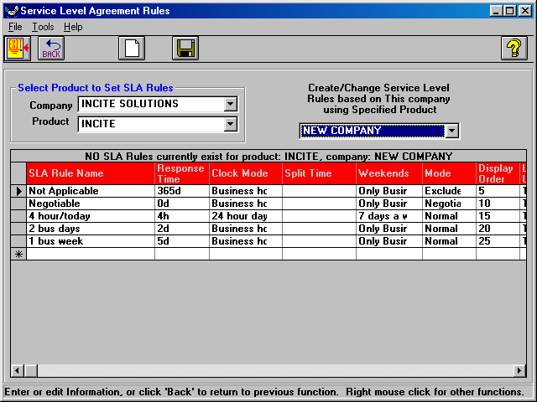
Set Product Level Defaults (Administration/Configuration/Set SLA Default Rules)

When the SLA Rules are defined between a product and a company, this activity enables you to default the applicable rule such that when a new Inquiry is added, the SLA process begins in the background. By completing the matrix for each product area, priority, and type you can predefine the SLA rule that applies. To facilitate setup, one can identify rows or columns and populate them with the appropriate default rule.

If a negotiable SLA is defaulted, you can enter the Must complete SLA by Date when an Inquiry is added or subsequently when an agreed to completion date is negotiated. This is changed on the Inquiry Screen – SLA tab. Defaulted SLA’s can also be changed on this tab when adding an inquiry or subsequently changing an Inquiry.

The following is an example of the information requirements to capture the SLA defaults.

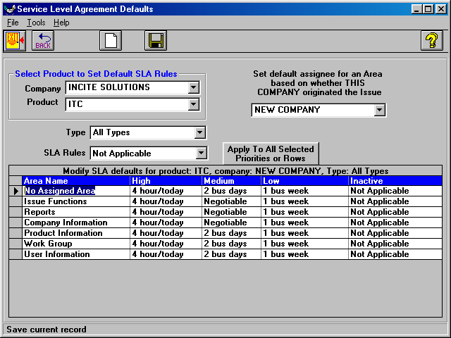

Inquiry Processing & Establishing SLA Rules

When adding a new Inquiry, the SLA tab is automatically displayed when the combination of Product Area, Priority, Type and Affiliated Company intersect. The Must complete SLA by Date is displayed and defaulted by the applicable rule for the combination. If you change Inquiry terms such as priority before saving the Inquiry, it will automatically adjust the Must complete SLA by Date.

One can also change any open SLA’s information by using the Inquiry Screen – SLA tab by modifying the rule. You will always want at least one negotiable rule. When that rule is picked,
ITC permits entry of a negotiated date.

SLA Completion

The SLA completion date (Inquiry was SLA completed on) is populated in one of three methods:

- Inquiry is completed and time/date SLA completed set to that time
- User manually hits the Complt SLA button on main toolbar (see below)
- Inquiry status is defined to automatically close SLA’s when a new phase is created with the appropriate status

Failed SLA’s are determined by comparing Must complete SLA by date, the calendar date, and Inquiry was SLA completed on date as identified on the Inquiry – SLA tab.

Extenuating circumstances occasionally requires that an Inquiry be overridden in terms of whether it passed or failed the SLA requirement. ITC provides the ability to Manually Pass or Manually Fail an inquiry by checking the appropriate block. If either of these blocks is checked, you are required to enter the reason for the override.

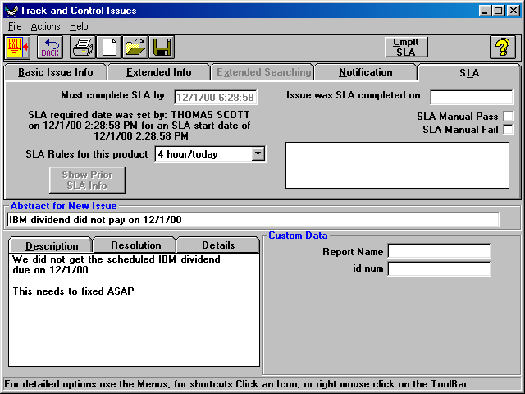

Special Searching

For negotiated SLA’s, ITC supports searching for Inquiries with SLA’s which do not have the Must complete SLA by date supplied. When searching from the Inquiry screen, use the Extended Searching tab and check No SLA Completion Date Defined.

This searching feature can be used alone or in conjunction with other search criteria. See the attached screen to implement the search criteria:

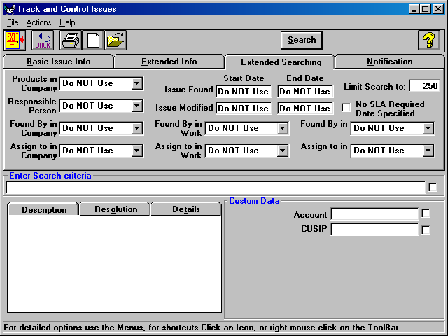

SLA Notification

Notification capabilities have been expanded to track SLA Failures. Users can be notified by adding to a specific Inquiry on the Inquiry – Notification Tab - On SLA Failure or through
establishing/modifying a notification profile through User Preferences-Notification-Notification Profiles

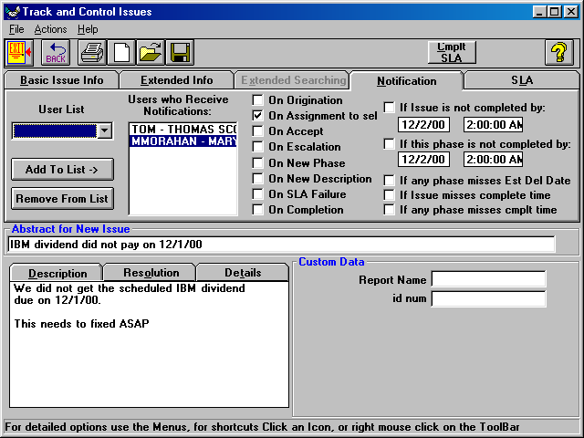

Reporting

The following standard reports are available to support the Service Level Agreements capabilities of ITC:

Report Name | Purpose
Service Level Agreement Rules | Used to validate setup of SLA rules
Service Level Agreement Defaults | Used to validate setup of defaults for a given product and customer relationship
Service Level by Area Summary | Periodic summary report which analyzes SLA performance by Product Area
Service Level by Area Detail | Detailed report showing each inquiry by Product Area as defined in the above summary
Service Level by Rules Summary | Periodic summary report which analyzes SLA performance by SLA Rule
Service Level by Rules- Details | Detailed report showing each inquiry by SLA Rule as defined in the above summary

Notifications

By default, when an SLA misses its scheduled completion date the current assignee is notified and the originator of the issue is notified.

Optionally, the Product Owner and Co-Owner and the Area Owner and Co-Owner may also be notified.

To turn on any of these optional notifications, bring up the System Options form and select the Notification tab. On this tab, in the frame “Notify when an inquiry misses its completion date” there are 4 check boxes.

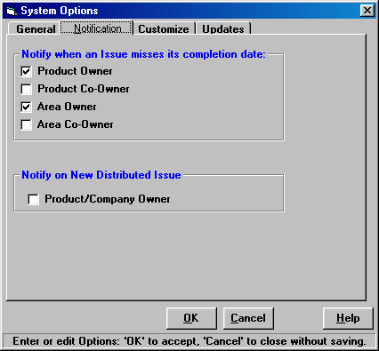

Each box corresponds to a notification to each of the Product Owner, Product Co-Owner, the Area Owner, and the Area Co-Owner.

By default none of these boxes are checked.

If the Product Owner and Area Owner are checked, then when an SLA misses its scheduled completion date the current assignee, the originator of the issue, the Product Owner, and the Area Owner will be notified.

Multiple SLA per Issue

By default, ITC can handle creates multiple SLAs per issue. While sometimes this can be a helpful feature, it may be confusing.

To limit the number of SLAs per call to 1, choose the Customize tab on the System Options form.
On this tab check the “Allow only 1 SLA per Issue” box.
Then click on the OK button.

