ITC Remote Access Documentation

In each operator record, there is a control to identify the access method for each user. Referred to as the ITC Access Mode on the User Screen, the choices and related ITC functional capabilities are as follows:

Access Mode | Functional Capabilities
E-mail * | Can originate Issues and update some information by  E-mail, no desktop license fee but annual usage charges. The  organization must license the e-mail Interface Engine.
On-Line | ITC is licensed for a given employee including report generation, searching, Issue modification, product maintenance, plus both WEB and e-mail access for Issue creation if the organization subscribes to those modules.
WEB | Can originate Issues from a client defined WEB page.  The issues are sent to the Escalation Manager via email.
Bound Remote | Counter parties at other organizations in a Distributed ITC environment. There are no fees associated with these users.
No Access | Interested party only. There are no fees associated with this class of user. They exist in the database for notification based on user profiles and for report distribution.

Note: Any user, whether licensed or not, is able to receive notifications as well as be the recipient of a report.

* Client needs to develop an e-mail form that is compatible with their electronic mail system, generally Lotus Notes or Microsoft Outlook.

Remote Issue Creation

With forms created as a Web page or in E-mail applications (such as Lotus Notes and Microsoft Outlook), authorized front office, back office, external agents, and even customers can initiate new Inquires into your ITC database.

When a new Issue is added to the ITC database, normal ITC processing occurs including authentication of the user, automatic assignment and routing of the Issue, notifying staff of assignments, creating SLA’s (Service Level Agreement Tracking), escalation, and notification to the originator upon completion.

This approach enables organizations using the ITC product to decentralize the capture of issues. If used internally, the form needs to be made available on your in-house intranet or e-mail server. If used by clients, external agents, or counter parties, all that is required is to make the web page available to the interested third parties within your current Internet security model or to distribute the appropriate e-mail form. You can distribute a Microsoft Outlook format to some and a Lotus Notes format to other external agents or clients, depending on their in-house e-mail systems. You may supply different front end web pages to different clients based on the product or customer knowledge.

Since virtually everyone is familiar with completing web forms or e-mail forms, no training or special software installation is ever required. New external agents can be set up quickly by merely providing the appropriate web address or mailing them the E-mail form with the appropriate loading instructions.

Web forms may be design by your staff or by Incite Solutions.
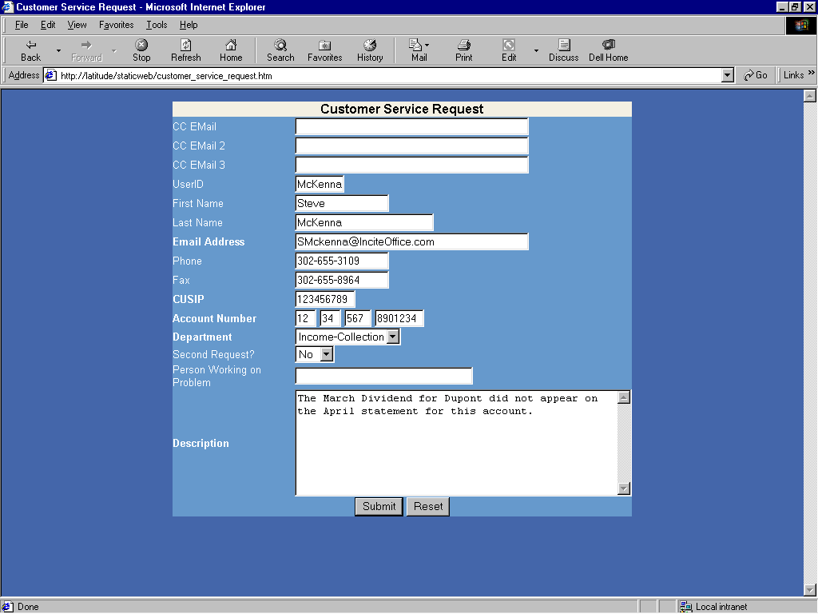

Forms may be very simple with few possible input choices:

Input fields such as Account number and CUSIP may be edit-checked on the form and/or flagged as required fields to reduce the occurrence of insufficient or poorly formed data input.

Or very complex DHTML forms with many choices and dependant combo boxes may be created. The following example actually add are removes fields as the choices in the Product combo are changed.
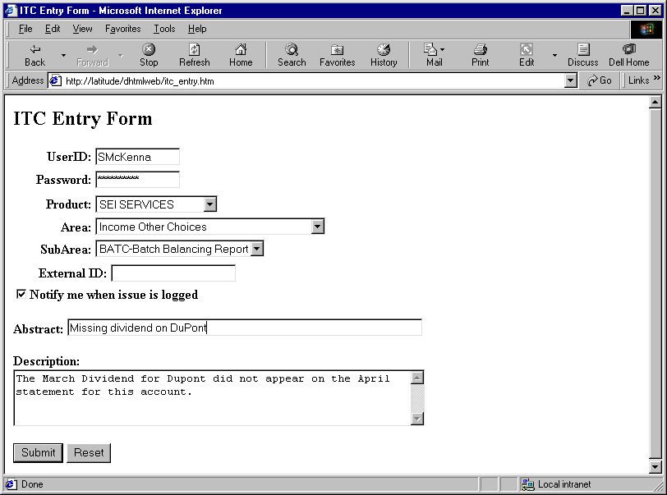

E-mail forms can be defined by your staff in the e-mail format consistent with your mail system. The example below shows simplicity and ease of completion for your staff.
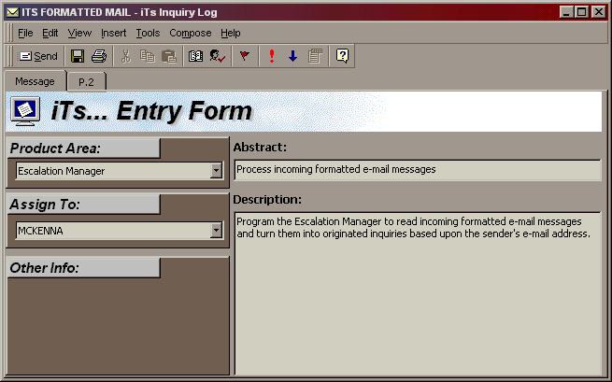

Many Issue categories like Type, Priority, and the Assigned to User can be defaulted based on how the product is defined. It minimizes the required information end users are required to provide.

Full Users of ITC can always change these fields after their initial evaluation. The system will support different forms for different products and services such that a user needs only to select the correct form, i.e. hardware versus trust services. The complexity of the forms and number of forms you have talking to ITC is your decision. An organization can have separate forms for each product or one complex form to support input into multiple products. Behind the form, special coding creates standard e-mail message formats that can be processed by the Escalation Manager in ITC.

General Issue Flow

The diagram below highlights the general flow of creating Issues via the Web or e-mail Interface. Regardless of the origin of the issue, all communication with the ITC database is via E-Mail with the Escalation Manager. The Web form generates E-Mail sent by the Web Server. Issues from an E-mail form are sent directly by the originating user.

Other E-Mail Features

Both Web and E-mail entered issues may be manipulated via E-mail. The following capabilities now exist to support those employees and external agents who do not have the ITC product on their desktop.

Update of External Number and Acceptance of Assignment to Third Party
Historically, ITC would notify a third party of an issue being assigned to them by
E-mail. If the third party ‘Reply’s’ to the e-mail and puts in the message ‘Incident: XXX’, the system will accept the issue for the third party and update the counter parties cross-reference number if available. Any message coming from the assigned counterparty after assignment will update the status as accepted.

Done
If this first line of the reply message has the word ‘Done’, when processed, it will reassign the Issue to the prior owner. If that person is from a different company, and there are SLA’s between the companies, it will change the status to the Complete SLA status code and stop the SLA tracking. If there is additional text in line 2 of the message and beyond, it will update that information into the new phase record.

Complete
If this first line of the reply message has the word ‘Complete’, it will create a new Completed phase assigned to the current owner of the Issue. It will stop any SLA activity on the Issue. If there is additional text in line 2 of the message and beyond, it will update that information into the new phase record. If the person completing the issue is a member of your company, it will copy the text not only into the Phase Description but also into the Resolution. If the person completing the issue is an external person, the Issue ‘Resolution’ will be left blank but the phase description will be coded as “Proposed Resolution’. When this occurs, the originator of the Issue is notified of the completion.

Update Issue
If a message is just responded to and no keyword such as Complete, Done, or Incident: are used, the text of the reply will be added to the current phase of the Issue and no other action will be taken.

Summary

Web and E-mail origination of issues afford organizations the opportunity to have limited ITC access on a large number of desktops without incurring the distribution headaches of a full desktop install. It also enables organizations the ability to distribute to customers and other agents an easy way to communicate with the organization and route messages to the appropriate staff. ITC can be configured to route requests from a given customer to their specified account team members based on their areas of responsibility.

