Reassign a person’s responsibilities

Previously, reassigning a person’s responsibilities in ITC was time consuming and complex. When terminating a user, ITC lists most of the roles a user has, but required the administrator to manually find each role, in its proper form, and to make the changes one at a time. The functionality “Reassign My Roles”, greatly simplify the process of reassigning a user’s roles. It also provides a quick and easy way for a user to note that they will be out of the office for short periods of time.

There are several occasions when you would like to reassign a person’s responsibilities:

- A departing employee who had many roles in the company, for example as an Area, Sub Area, or Work Group owner or co-owner
- A person who is on extend leave of absence
- A person with many different roles who will be out for a day or a week or two

In each case we would like to reassign all of the persons roles to new people.

The “Reassign My Roles” activity permits each person maintain their own availability, or for the System Administrator to manage all users availability. The “Reassign My Roles” activity has been added to the main user navigation menu, for quick access:

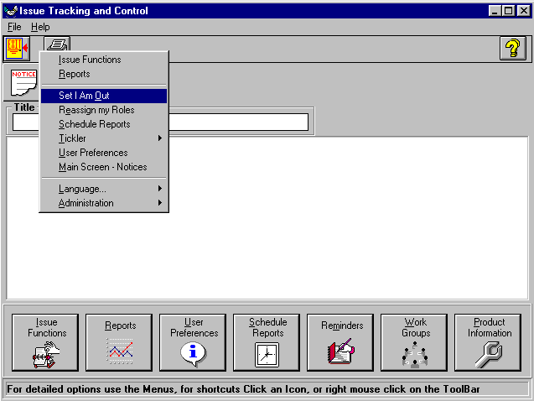
Figure 1

The “Reassign My Roles” activity

When a user will be out for an extended period and has many different roles in the ITC system, it may be desirable to reassign each of the roles individually.

The “Reassign My Roles” activity allows all of the roles of a user to be reassigned individually to different people.

A combo box will display the user to modify. This user will be automatically set (and unalterable) if an individual user selects this form to manage their own vacation time or if the form pops up from the User form to handle terminating an employee.

Once the desired user has been selected, the grid will be filled in with all of the roles that user has in the database. The grid will allow each role to be assigned to a different person.

System Administrators and users with the proper Security settings may change all roles. Product, Area, and Sub Area owners may change roles under their specific purviews.

For a terminating user, all roles must be reassigned or the user may not be terminated.

Sensibly for a vacationing user, all roles should be reassigned, but it is not required.

In figure 3, the selected user TMULLEN would like to reassign her roles, she has clicked on the “Show All Roles” button to display all of her current roles.

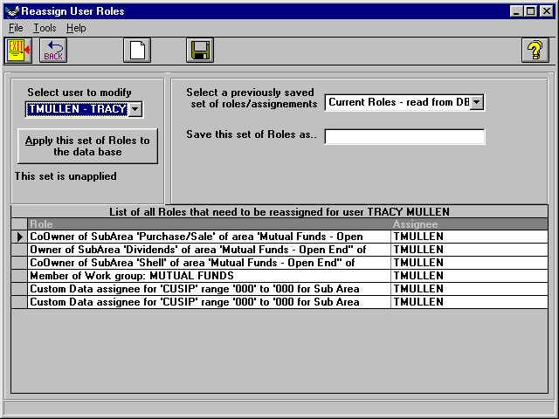
Figure 2

After displaying the current roles, Tracy then selects the appropriate people to handle each of her roles while she is out of the office. If there is no backup person, then she may simply leave her name in the assignee column or she may select the “None” user to have her role skipped and the assignment move on to the next person in the escalation chain.

A set of roles and assignees may be saved for latter reuse by supplying a name for the roles set and clicking on the “Save this set of Roles as...” button. This simplifies the process of reassigning roles.

By default, the first set of roles displayed will be the current roles the user has in the database.
If a set of roles and assignees has previously been saved, it may be recalled by selecting it from the “Select previously Saved Roles” combo box.

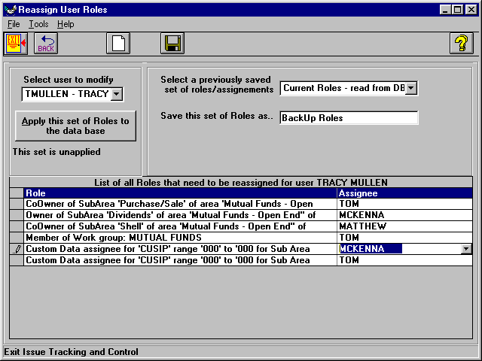
Figure 4

Saving a set of roles and assignments does NOT apply them to the database. A set of role assignments may be set up and saved at any time. To actually apply these reassignments to the database, click on the “Apply this set of Roles to the database” button. Once the “apply” button has been clicked, all of the specified roles will be reassigned, immediately.

Once the “Apply” button has been clicked, all of the specified roles will be changed in the database. These changes take effect immediately and remain in effect until there are rolled back. There is no automatic time out or ending effective date.

The changes remain in effect until they are rolled back.
An applied set of role assignments may be rolled back.

Select the desired set of roles from the “Select a previously saved set of roles/assignments” combo. Roll sets that have been applied will display the time and date they were applied. Now click on the “Rollback this roll set” button.

TMULLEN will be reset as the role owner for each of the role/assignments.

If, in TMULLEN’s absence a role has been manually reassigned, the rollback operation will NOT restore TMULLEN to the role.

In this example, if the Owner of the Mutual Funds area went into the Product activity and selected MCKENNA as the new CoOwner of the “No Assigned Sub Area” for Mutual Funds, then the rollback of TMULLEN’s “Backup Roles” would not replace MCKENNA with TMULLEN.

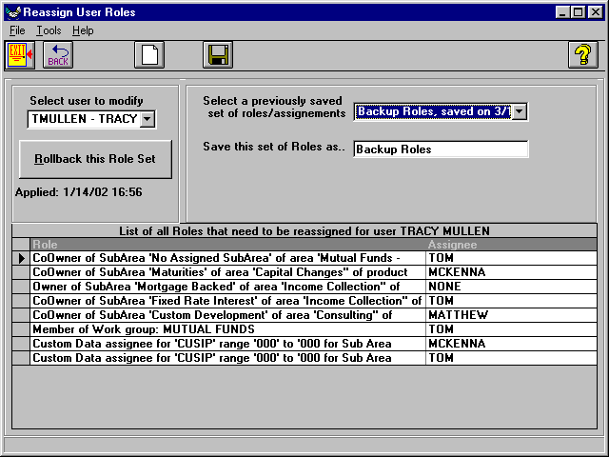
Figure 5

Administrators may find who currently has roles in the database by using the Tools menu choice “Get Next User With Roles” (Ctrl-R). This will select the next user who has any roles in the database. Using the Tools menu choice “Get Next User With Applied Roles” (Ctrl-A) an administrator may find people who have applied a set of role changes to the database. This eases role-changing maintenance.

