Escalation Monitoring

The ITC Escalation Manager was originally designed to run on a computer at an end user’s desk. That made it easily available for monitoring and maintenance. However, the insecurity of this arrangement has led some clients to run the Escalation Manager from inside a secure ‘server’ room. This presents some problems, for the Escalation Manager expects a certain level of user interaction to deal with problems that arise as it runs. This led to the creation of remote monitoring tools for the Escalation Manager.

There are currently two monitoring tools for the Escalation Manager, ‘Web Monitoring’ and the ‘Escalation Monitor’ application.

Web Monitoring
The first monitoring tool is a web page that gives a snapshot of the current state of the Escalation Manager.

Here is an snapshot of the Escalation Manager in a stopped state:

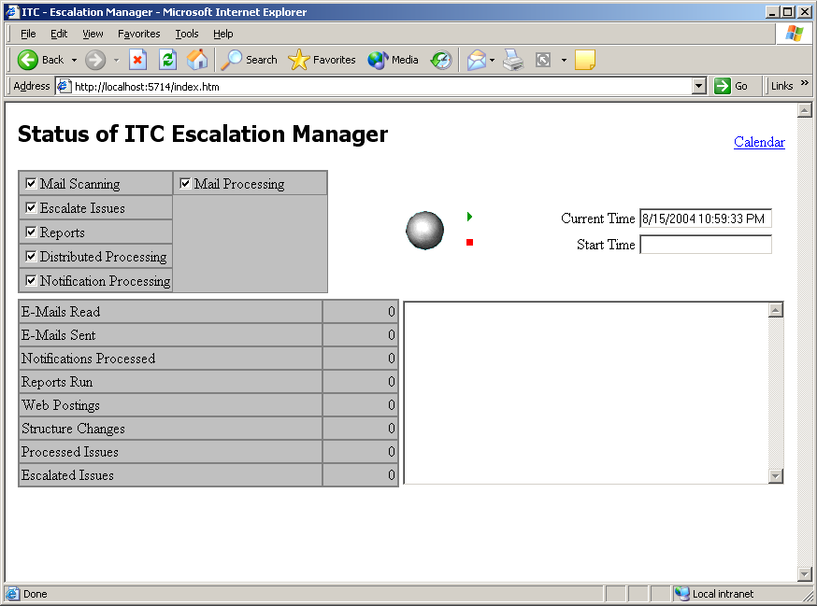

There is no Start Time, nothing in the log area, and the ‘silver ball’ is idle. Compare this to the actual Escalation Manager in the same state:
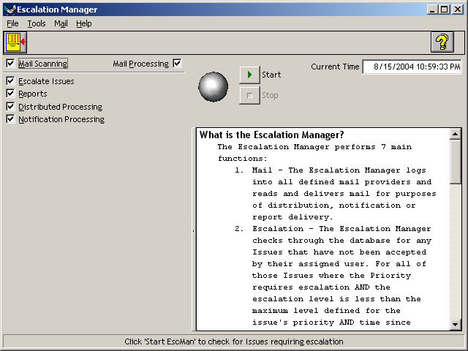

When the Escalation Manager is running, the web page looks like this:
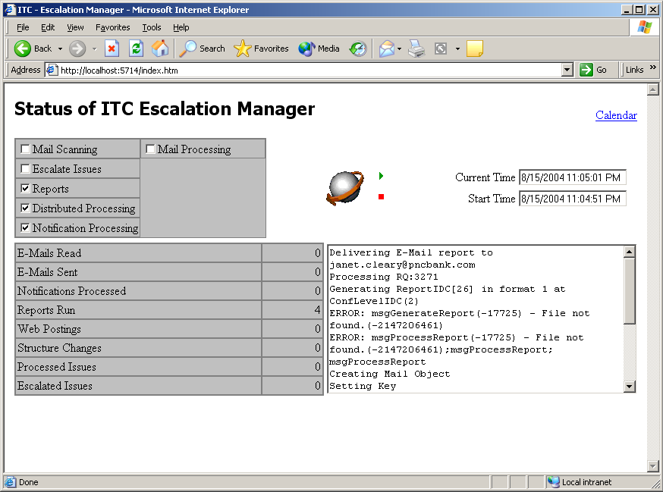

You can see that the Start Time now shows when the Escalation Manager was started, the log is full of information (including some error messages), and the ‘silver ball’ shows its running state. Also, you can see that several of the processing options have been unchecked.

If the Escalation Manager is either crashed or not running at all, the web monitor will fail to connect:
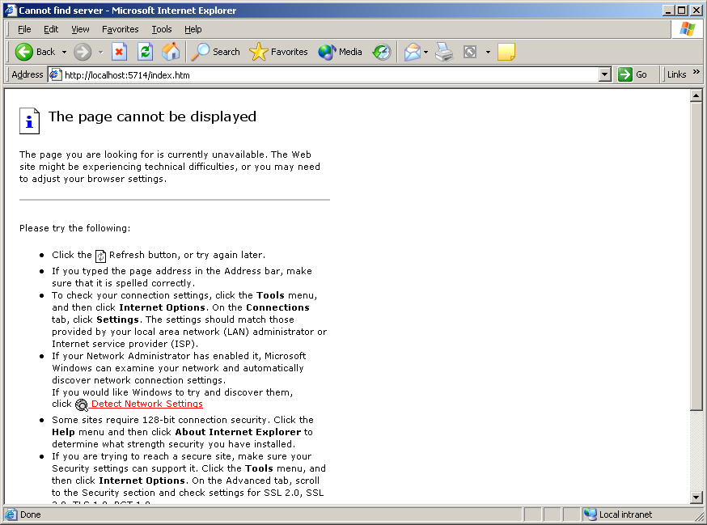

This shows that there is a SERIOUS problem with the Escalation Manager and requires immediate user intervention.

Escalation Monitor
A more substantial level of monitoring is available through the ‘Escalation Monitor’ application. This application needs to be installed on a user PC using the Escalation Monitor wizard.

The monitor application is launched, and the user logs in with their ITC user id and password. The Monitor application comes up showing the ‘Calendar’ view for a snapshot of the current ITC issue workload:
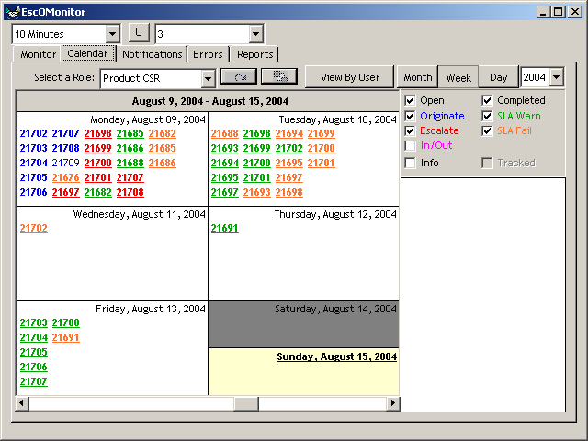

This calendar works the same as the ‘Personal Calendar’ function in the ITC application.

The two combo boxes at the top of the window set the ‘Refresh Interval’ (10 Minutes) and the ‘Problem Threshold’ (3). The ‘Refresh Interval’ sets how often the various tabs will be refreshed from the database. The ‘Problem Threshold’ is relates to inactivity warnings on the query tabs explained below.

Here is the ‘Monitor’ tab:
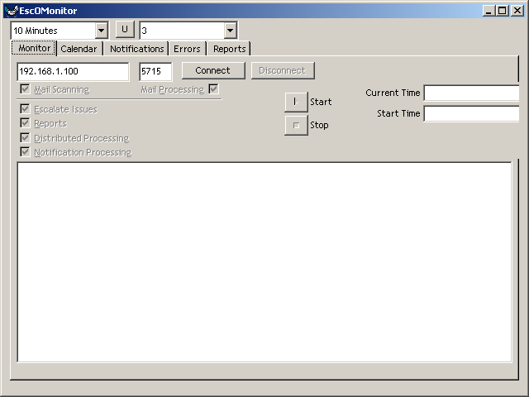

This function is an advanced version of the Web Monitor functionality. It more closely duplicates the Escalation Manager look, and adds the functionality of being able to start and stop the Escalation Manager, and enable/disable the various functions of the Escalation Manager.

When the monitor application it launched, it is disconnected from the Escalation Monitor. The Monitor application gets the IP address and monitor port for the Escalation Manager from the System Options table and fills these in automatically.

To attempt a connection, click ‘Connect’.

If the Monitor cannot connect to the Escalation Manager, an error message will appear. This means that either the Escalation Manager is not running or possibly, but unlikely, that the IP address/port information is wrong.

When the Monitor successfully connects to the Escalation Manager, it will read the state of the Escalation Manager:
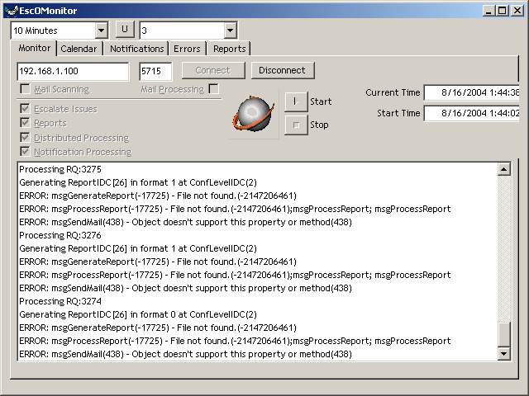
You can see the Current Time and Start time are filled in, the globe is animated, and the log is showing a spate of error messages (the monitoring in these examples show many error messages because the environment under which this documentation is being written is not a valid Escalation Manager environment. It is a locked down ‘sandbox’ which doesn’t allow any disk or mail access, hence the errors). The check boxes and Start/Stop buttons are disabled because I signed in to the monitor as a run-of-the-mill operator, not a system administrator. If I logged in as an administrator, I would have remote control over the functionality of the Escalation Manager:
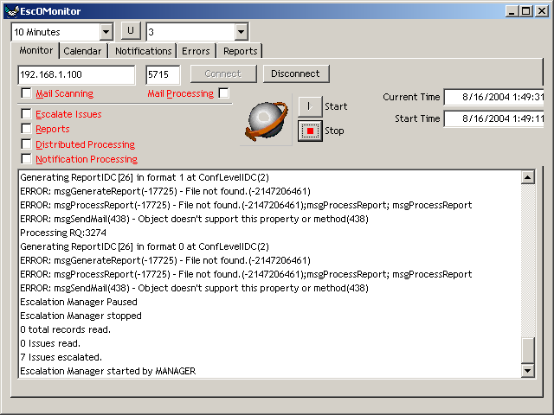
Here, as an administrator, I have unchecked all the functionality (when the Escalation Manager acknowledges the new state, it turns the labels red), and I have the ability to Stop the Escalation Manager. This will not quit or relaunch the Escalation Manager application, however it will suspend all processing. One thing to remember is that it is truly a remote control. There is no ‘state’ information stored on the Monitor. Therefore, it may take several moments for an action on the Monitor to have an effect that can be seen in the log. The Escalation Manager works in bursts of activity every minute, and it will not see the change in state until its next processing interval, when it will report that change back to the Monitor.

You may wonder where the various ‘counts’ are from the left hand side of the Escalation Manager screen. That will have to wait until Version 2.0. I thought it was more important to have a nice big log area to diagnose problems than have a bunch of counts that really don’t tell any immediately important info. Regardless, the web monitor will still give you those counts if you need them.

In summation, the Monitor portion of the Escalation Monitor application can literally remotely control the Escalation Manager application. It continually reflects the state of the Escalation Manager and is refreshed automatically when the Escalation Manager goes through its processes. The controls on the Monitor send messages to the Escalation Manager application, affecting it exactly as if someone had checked the boxes or pushed the buttons on the machine (even the dialog box that asks to confirm a ‘Stop’ command from Escalation Monitor pauses the Escalation Manager as if you had clicked the stop button on the Manager itself.

Query Tabs
The remaining functionality of the Escalation Monitor is the ‘Query Tab’ function. This is a collection of queries that run against the database, looking for certain types of activity that are good indicators of the health and well-being of the Escalation Manager, the database system, mail system and ITC system in general. These do not connect to the Escalation Manager in any way, and can be run even while the Escalation Manager is down or paused.

These queries are updated at the interval set in the ‘Refresh Interval’ combo box. The colors of the grid will evolve according to a formula using the ‘Refresh Interval’ and the ‘Problem Threshold’. Under normal circumstances, the contents of the grid will start out green. If, for example, the Problem Threshold is set to 3 and the Refresh Interval is set to 10 minutes, after 30 minutes of inactivity, the grid will turn yellow. After a further 30 minutes of inactivity, it will turn red. All the examples in this document are red, because months have elapsed since the data was updated. This is a rather subtle mechanism, and all the details haven’t be worked out yet, so for now just read the contents, and don’t be surprised if it is green, yellow or red.

(You may notice a lag between the clicking of the tab and the appearance of the query grid. These are rather complex queries)

The first Query is ‘Notifications’:
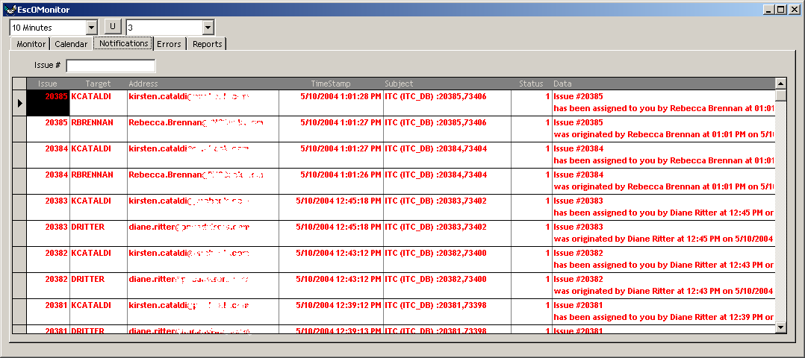
This tab comes up with the 20 most recently sent (newest at the top) notifications. You can see the Issue #, the recipient’s UserID, the target e-mail address, the time the message was sent, the subject of the email and the actual body of the message, the rows and columns can be resized to show more of the body. In this example, the most recent notification was sent to KCATALDI at 1:01 PM on May 10, 2004. The Escalation Manager here has been idle for a long time.

The Issue # entry box allows you to see the notifications for a particular Issue. For example, if there is a question about people being properly notified about Issue #3521, just enter 3521 in the box and hit Tab. The grid will refresh:
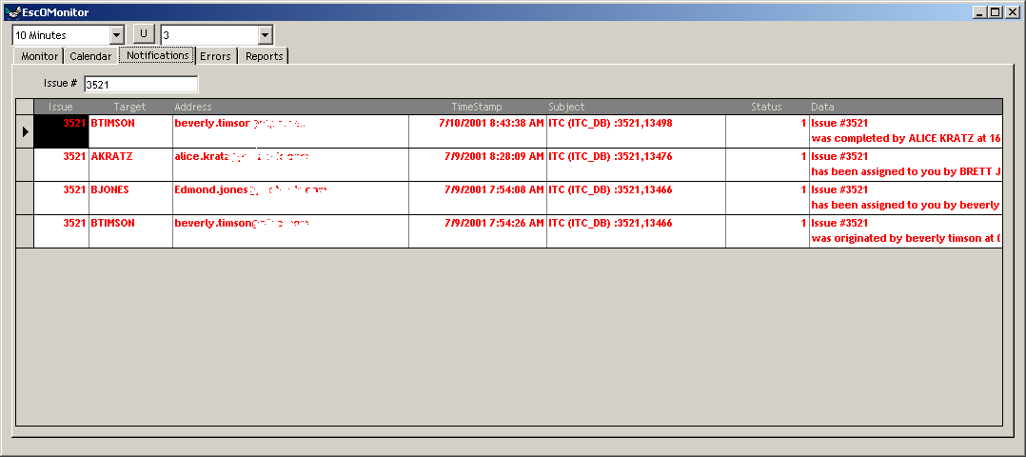
You can see that Issue #3521 was originated by BTIMSON at 7:54 am on July 9, 2001. It was assigned to BJONES. BJONES assigned it to AKRATZ. AKRATZ completed it at 8:43 am on July 10, and BTIMSON, the originator, was notified about the completion. This is a normal notification cycle.

To reset to the full database query, simple clear the Issue # box and hit Tab.

Next up, Reports:
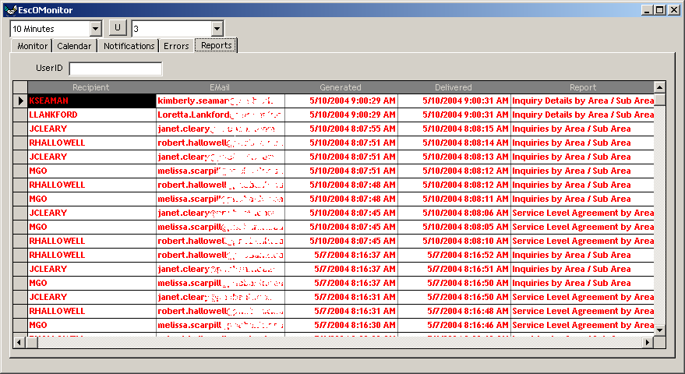
This shows the most recently delivered reports, who received it (and their e-mail address) and when it was delivered. The list can be filtered by Recipient. Type the Recipient’s UserID into the UserID box and hit Tab:
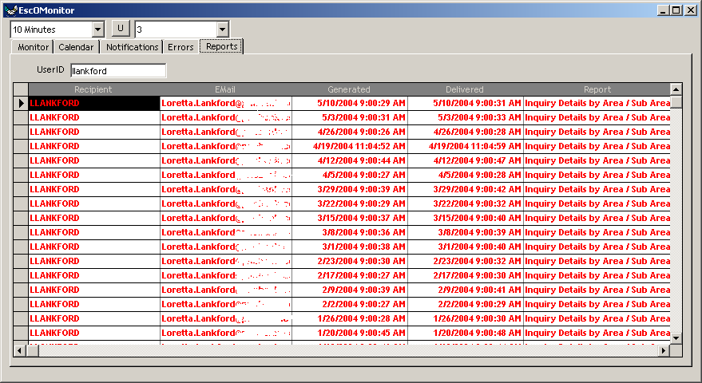

You can see that LLANKFORD has received the Inquiry Details by Area / Sub Area report every Monday at 9:00 am.

Finally, the ‘Errors’ tab:
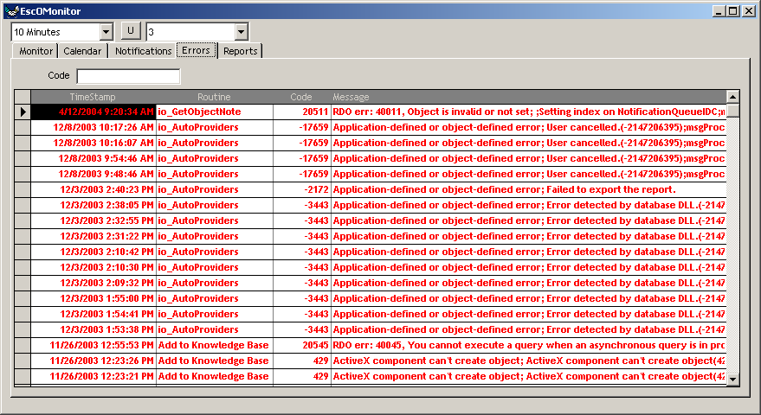
This tab shows a list of the errors that have jammed up the Escalation Manager in the past. The most recent error happened at 9:20 am on April 12, 2004. Since this is long before the most recent notification, it’s a safe bet that the Escalation Manager is NOT stopped by an catastrophic error. However, if the most recent error is sooner than any of the notifications or reports, than error shown may have stopped the Escalation Manager processing. You can filter the list by ‘Code’ in order to see a trend of similar errors:
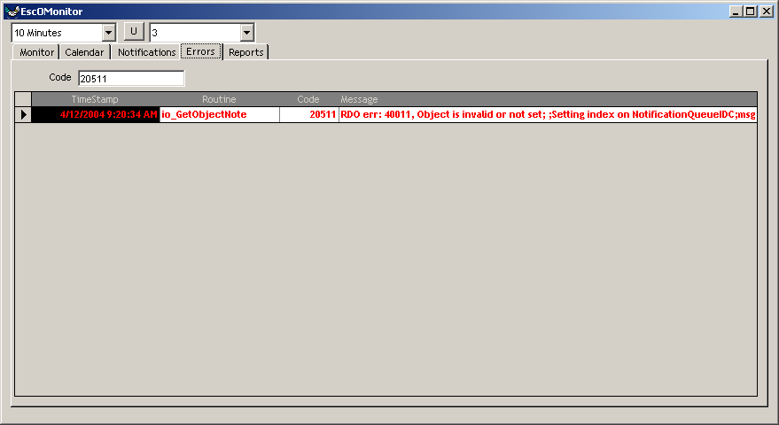
You can see that the error on April 12 was the first and only one of its code in the history of the ITC system.

Technical Details
When the Escalation Manager is launched it looks in the SystemOptions table for a value in the ‘ESCOMANPORT’ record. If this record is missing, or the value is blank or ‘NONE’, no monitoring functionality will be enabled or available.

However, if the ESCOMANPORT value is filled in, the Escalation Manager will perform the following steps:
- It will get the IP address of the primary network connection for the machine on which it is running and write this value into the SystemOptions table in the ESCOMANIP record. This is the IP address/port that the Monitor application uses to connect to the Escalation Manager.
- It will listen on the specified port for web connections. This is the port to be used for Web Monitoring. You can see in the Web Monitor screenshot, the browser has connected to ‘localhost’ on port 5714. This is the default port, but it can be changed by changing the value in the ESCOMANPORT record in the SystemOptions table. The Escalation Manager actually operates as a small, simple web server. It accepts HTTP requests and responds with the properly formatted HTML and image files as required for the Web Monitor functionality.
- It will listen on the specified port + 1 (ie. 5715) for Escalation Monitor connections. You can see in the Monitor Application screenshot that it is connecting to IP address 192.168.1.100 on port 5715. The communication on this port is a series of XML packets that encapsulate the activity and status of the Monitoring functions.
These ports will remain open as long as the Escalation Manager is running. Changing the value of the ESCOMANPORT while the Escalation Manager is running will have no effect. The Escalation Manager needs to be restarted to recognize the new value.

The important thing from an IT infrastructure standpoint is that the Escalation Manager will open two ports on the Escalation Manager, and remote machines need to connect to one or both of these ports for monitoring purposes. These IP and port configurations only affect the Web Monitoring and the Monitor tab on the Monitor Application. Even with the ports closed (by deleting or clearing the ESCOMANPORT value), the Query Tabs and Calendar will still work fine.

