I Am Out

The functionality “Set I Am Out” provides a quick and easy way for a user to note that they will be out of the office or unavailable for short periods of time.

When a person is out of the office or unavailable for a period of time it may be best not to assign any new issues to the person while they are out. In this case we just need to alert ITC not to assign new issues to the person for the specified period, in essence skip the escalation period and jump directly to the next person in the escalation chain.

The “Set I Am Out” activity permits each person maintain their own availability, or for the System Administrator to manage all users availability. The “Set I Am Out” activity has been added to the main user navigation menu, for quick access:

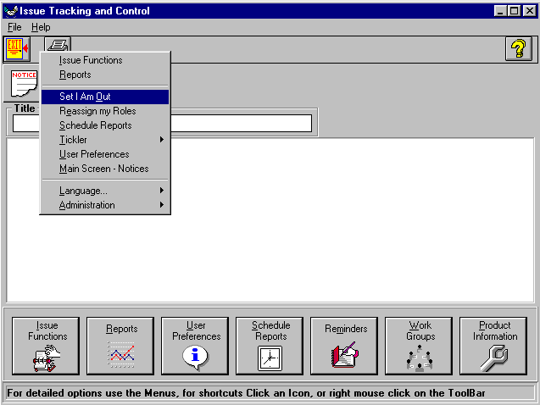
Figure 1

To access the main user navigation menu, click on the “File” menu on any screen, then click on the “Display Menu” selection, this will pop up the ITC navigation Menu. Click on the “Set I Am Out” selection from the navigation menu.

The “Set I Am Out” activity

The “Set I Am Out” activity handles people being unavailable for the day or afternoon or some period of time. If the user marks themselves as “Out” then no new issues will be assigned to them and they will not participate in the escalation chain. Issues that would have been assigned to the user will no longer be assigned to them. If the user does NOT select a replacement person (the replacement person will be shown as “NONE”) the assignment of the issue will immediately jump to the next person in the escalation chain. If a replacement person is specified, new issues will be directly assigned to that person. When the “I am out” period expires, the user will again be assigned issues in the normal sequence.

When marking themselves as “Out” the user may specify an individual to replace them for all assignment and escalation purposes. If such a person is specified, that person will now be assigned all issues that would previously have been assigned to the person who is “Out”. When the “I am out” period expires, the original user will again be assigned issues in the normal sequence. Figure 1 shows user “Tom Scott“ noting that he will be out of the office for 4 hours:

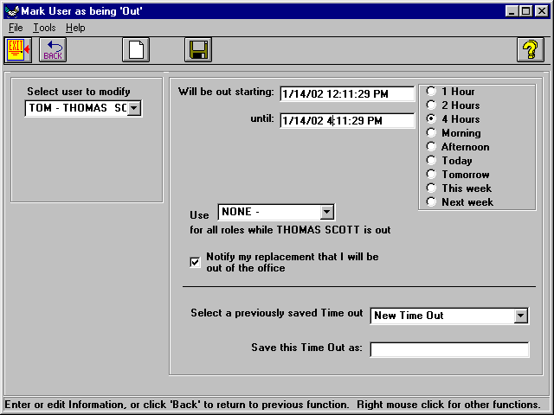
Figure 2

The “Select user to Modify” combo box displays the user who will be out. This combo box will be automatically set (and unalterable) if an individual user selects this form to manage their own meeting or vacation time. System Administrators may set or alter “I Am Out” times for any user.

Prior to saving, a description for the outage must be supplied, such as “Management Meeting”. The “Select a previously saved Time Out” box may be ignored.

To mark the user as “Out”, click on the “Save” icon.

Step-by-Step Directions:
- Select the times you will be out
- Select a replacement user (or leave as “None”)
- Put title in “Save this time out box
- Click on the “Save” icon on the tool bar
After clicking the “Save” icon, the user is marked as “Out”. If the user has specified they will be out starting now, a box will pop up confirming that they will be out for the specified time period and ask if they would like to flagged as “In”. It is anticipated that the user will simply leave this dialog box up on the screen and proceed to their meeting. If they return from their meeting early, they may simply click on “yes” to be marked as “In” immediately.

Generally, you will be exiting the application and proceeding to your meeting, you should click “NO”, and then exit ITC.

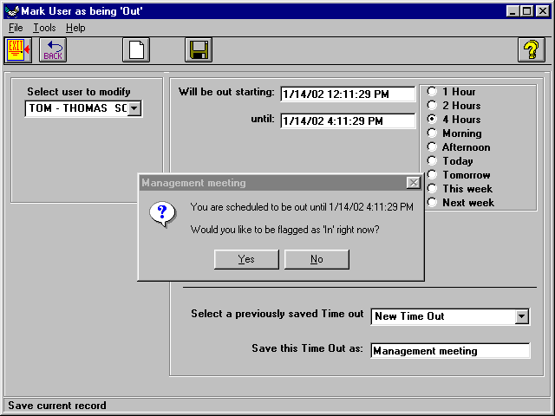
Figure 3

If the user returns late from their meeting, the system will automatically marked them as “In” when the specified end time occurs, even if the dialog box is still displayed or the user answers “No”.

If you are marked as “Out” for the day and return early and log into ITC, this dialog box will also pop up and prompt you with a dialog box to mark you as “In”. If you wish to begin receiving new issue, you should click on the “Yes” prompt.

You do not have to answer “Yes” or leave the dialog box up. If your meeting starts in 10 minutes, and you wish to be considered “Out” starting now, but wish to continue working in ITC, just click on “No”. The following message will confirm you “Out” designation, but allow you to continue working in ITC:

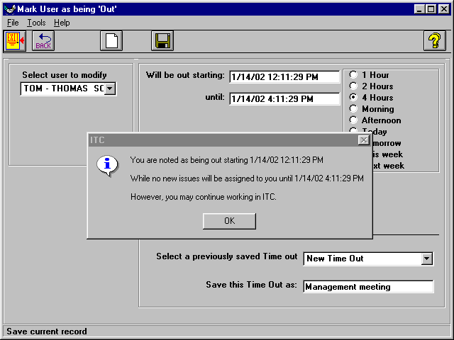
Figure 4

If you return early from your meeting, to mark yourself as “In”, just return to the “I Am Out” form. The dialog box shown in figure 3 above will automatically be displayed. Click on “Yes” to be immediately marked as “In”.

You may schedule outages for any time. In the morning you may schedule an afternoon meeting or that you will be out the next day or week. When the start time arrives, the system will automatically skip you in the assignment and escalation process.

If a replacement assignee is specified, an e-mail message may optionally be sent to the replacement assignee alerting them that they have been designated as the replacement assignee for the specified period. No e-mail will be sent if user just says, “I am out” and does not specify a new assignee, i.e. “None”, because the person who will be assigned the issue would have been assigned the issue normally (as a result of the escalation sequence).

In Figure 5 below, Tom Scott has referred all of his issues to Steve McKenna for the 4-hour period he will be out and has requested that Steve be notified of this referral.

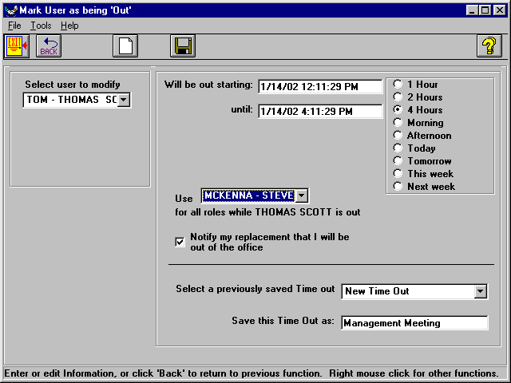
Figure 5

The “Notify my replacement” check box is checked by default.

This form permits an individual user to note their unavailability due to meetings simply and easily. The form will default their name into the “Select a User” combo box. The user need only click on the number of hours they will be out or fill-in the times manually, select a replacement person (or leave as “None” to skip to the next person in chain), and then click on the “Save” icon.

When the specified time expires, the user will again be automatically assigned issues.
If the user returns before the specified expiration time, ITC will prompt the user if they are ready for work to be assigned to them again. Optionally the user may return to the form and adjust any current “I am Out” times.

Administrators Functions:

Administrators may find who is currently listed as “Out” by using the Tools menu choice “Get Next User Who is Out” (Ctrl-R). This will select the next user who has specified that they will be out right now. Using the Tools menu choice “Get Next User who is out, based on specified start date” (Ctrl-A) an administrator may find people who a slated to be out at any point in the future or past, by entering the desired date/time in the “Will be out staring” field, then pressing Ctrl-A.

When a user will be out for an extended period or has many different roles in the ITC system, it may be desirable to reassign each of the roles individually. Please refer to the “Reassign My Roles” activity for further information.

