ITC Email Overview

Background

Since inception, the foundation of ITC was closely coupled with standard office suites being used on most desktop computers. Until recently, that integration was primarily associated with:

- Notification via e-mail on assignment, completion, or escalation of an Inquiry
- Notification on critical events based on user profiles
- Alternative delivery method for scheduled reports
- Underlying architecture for Distributed ITC product

Release 1.8, which was installed during the first quarter of this year and Release 1.9 that will be available this month dramatically changes the level of office solutions integration. These releases offer a new method to gain many of the benefits of ITC without the need to install or incur the cost of the ITC application on every desktop.

The new ITC e-mail Interface Engine is now available for license. It has an initial license fee and is supported with annual software maintenance and usage fees based on the number of e-mail users of ITC.

In each operator record, there is a control to identify the access method for each user. Referred to as the ITC Access Mode on the User Screen, the choices and related ITC functional capabilities are as follows:

Access Mode | Functional Capabilities
E-mail * | Can originate Inquiries and update some information by  e-mail, no desktop license fee but annual usage charges. The  organization must license the e-mail Interface Engine.
On-Line | ITC is licensed for a given employee including report generation, searching, Inquiry modification, product maintenance, plus both WEB and e-mail access for Inquiry creation if the organization subscribes to those modules.
WEB | Can originate Inquiries from a client defined WEB page.  The organization must subscribe to the WEB Interface  Engine. Initial WEB license fee, software maintenance, and  a usage fee based on the number of WEB users.
Bound Remote | Counter parties at other organizations in a Distributed ITC environment. There are no fees associated with these users.
No Access | Interested party only. There are no fees associated with this class of user. They exist in the database for notification based on user profiles and for report distribution.

Note: Any user, whether licensed or not, is able to receive notifications as well as be the recipient of a report.

* Client needs to develop an e-mail form that is compatible with their electronic mail system, generally Lotus Notes or Microsoft Outlook.

E-mail Based Inquiry Creation

The new module is based on popular e-mail solutions such as Lotus Notes and Microsoft Outlook. With forms created in the e-mail applications, authorized front office, back office, external agents, and even customers can initiate new Inquires into your ITC database.

When a new Inquiry is added to the ITC database, normal ITC processing occurs including authentication of the user, automatic assignment and routing of the Inquiry, notifying staff of assignments, creating SLA’s (Service Level Agreement Tracking), escalation, and notification to the originator upon completion.

This approach enables organizations using the ITC product to decentralize the capture of issues. If used internally, the form needs to be made available on your e-mail server. If used by clients, external agents, or counter parties, all that is required is to distribute the appropriate e-mail form. You can distribute a Microsoft Outlook format to some and a Lotus Notes format to other external agents or clients, depending on their in-house e-mail systems.

Since virtually everyone is familiar with completing e-mail forms, no training or special software installation is ever required. New external agents can be set up quickly by merely mailing them the form with the appropriate loading instructions.

E-mail forms can be defined by your staff in the e-mail format consistent with your mail system. The example below shows simplicity and ease of completion for your staff.

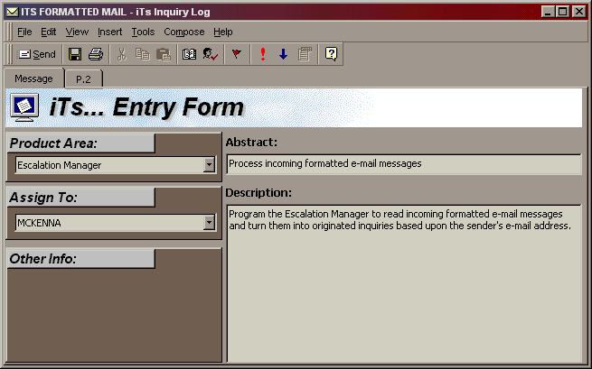

Many Inquiry categories like Type, Priority, and the Assigned to User can be defaulted based on how the product is defined. It minimizes the required information end users are required to provide.

Full Users of ITC can always change these fields after their initial evaluation. The system will support different forms for different products and services such that a user needs only to select the correct form, i.e. hardware versus trust services. The complexity of the forms and number of forms you have talking to ITC is your decision. An organization can have separate forms for each product or one complex form to support input into multiple products. Behind the form, special coding creates standard e-mail message formats that can be processed by the Escalation Manager in ITC.

General Inquiry Flow

The diagram below highlights the general flow of creating Inquiries via the e-mail Interface. They can be created by your employees (Internal Users) who have access to your e-mail system or from clients, counter parties, or remote employees (External Users) via Internet e-mail.

Other E-Mail Features

Much of the focus of release 1.8 was to provide e-mail extensions to the ITC product to effect status changes and sharing of information. The following capabilities now exist to support those employees and external agents who do not have the ITC product on their desktop.

Update of External Number and Acceptance of Assignment to Third Party
Historically, ITC would notify a third party of an inquiry being assigned to them by
e-mail. If the third party ‘Reply’s’ to the e-mail and puts in the message ‘Incident: XXX’, the system will accept the inquiry for the third party and update the counter parties cross-reference number if available. Any message coming from the assigned counterparty after assignment will update the status as accepted.

Done
If this first line of the reply message has the word ‘Done’, when processed, it will reassign the Inquiry to the prior owner. If that person is from a different company, and there are SLA’s between the companies, it will change the status to the Complete SLA status code and stop the SLA tracking. If there is additional text in line 2 of the message and beyond, it will update that information into the new phase record.

Complete
If this first line of the reply message has the word ‘Complete’, it will create a new Completed phase assigned to the current owner of the Inquiry. It will stop any SLA activity on the Inquiry. If there is additional text in line 2 of the message and beyond, it will update that information into the new phase record. If the person completing the inquiry is a member of your company, it will copy the text not only into the Phase Description but also into the Resolution. If the person completing the inquiry is an external person, the Inquiry ‘Resolution’ will be left blank but the phase description will be coded as “Proposed Resolution’. When this occurs, the originator of the Inquiry is notified of the completion.

Update Inquiry
If a message is just responded to and no keyword such as Complete, Done, or Incident: are used, the text of the reply will be added to the current phase of the Inquiry and no other action will be taken.

Blind Reply

By sending an e-mail to the Escalation Manager’s e-mail box with the subject of the Inquiry being Inquiry XXX, ITC can now process the following actions:

- Update External ID
- Accept an Inquiry
- Done Processing
- Complete Processing
- Update Basic Inquiry Text
- Receive Schedule Reports

These features meet many of the needs that your staff has for basic Inquiry processing. Fully licensed ITC users can also:

- Manage Products, Departments, and Areas
- Manage Products and Product Defaults including priorities and types
- Maintain Security
- Do extensive Searching
- Generate and/or Schedule Reports
- Log and Process Inquiries

Summary

These enhancements afford organizations the opportunity to have limited ITC access on a large number of desktops without incurring the standard licensing fees. It also enables organizations the ability to distribute to customers and other agents an easy way to communicate with the organization and route messages to the appropriate staff. ITC can be configured to route requests from a given customer to their specified account team members based on their areas of responsibility.

