ITC – User Calendar Documentation

Events:
There are five types of events, four of which are concerned with issues:
- Originate – When the issue was originated
- Escalate – When the issue will/did escalate
- SLA Warn – When the issue will/did reach 80% of its SLA period
- SLA Fail – When the issue will/did fail its SLA

The fifth type of event, In/Out, shows when the Active User is/was marked out of the office.

As you can see in the example of above, Issue #8953 enters the world with all four events. An Originate event on the date the issue was originated. An Escalate event on the date the issue will escalate. An SLA Warn event on the date the issue will warn, and an SLA Fail event on the date the SLA will fail. All the numbers are bold, because the issue is still open. The numbers are not underlined, because the events are all in the future (except the Originate event which can never be in the past, so will never be underlined)

If this call is never modified, never accepted or completed or anything, this display will evolve. The tan box will proceed through the days. As the Escalate event is passed, it will change from bold to plain, and a new Escalate event will appear, in bold, for the new assignee of the issue. The other events will be underlined as they are passed, but no new SLA events will be created as they are passed.

If the issue is accepted before the Escalate event, the Escalate event will disappear. It is no longer an active event for this issue. The SLA events will remain.

If the issue is completed before the SLA Warning event, both SLA events will disappear and the Originate event will change from bold to plain (because the issue is now complete).

If the issue is completed after the Warning, but before the Failure, the Warning will change from bold+underlined (it is underlined because it is in the past) to plain. The Originate event will change to plain, and the SLA Fail event will disappear.

If the issue is completed after the SLA Fail event, the Originate, Warn and Fail events will change from bold to plain.

As you can see in the following screen shot, all the events will be mixed and mashed together for any given day:
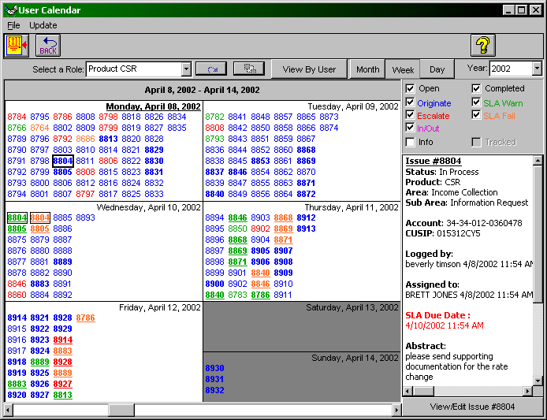
The selected issue, #8804, was Originated on April 8th, Warned on April 10th, and Failed later that day. It is still open (because the numbers are bold), but all in the past (because they are underlined)

You can see the summary on the right, and the View/Edit button below that.

Switching to Info mode:
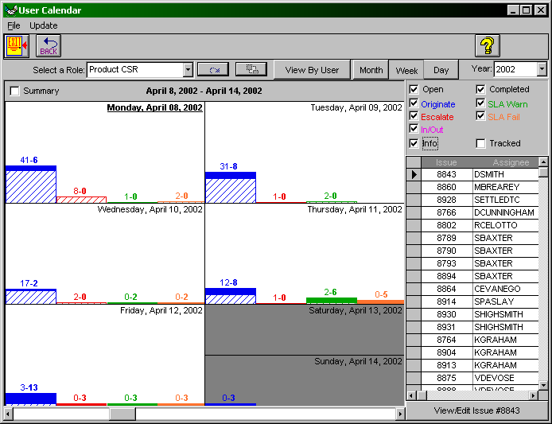
you can see that 47 issues were Originated on April 8th, 6 of which are still open. 8 issues escalated, 1 warned and 2 failed all on that day. The summary area has changed to a grid, listing all the issues that are represented in the entire calendar area. Selecting a row of the grid enables the View/Edit button for that issue.

Switching to Tracked:
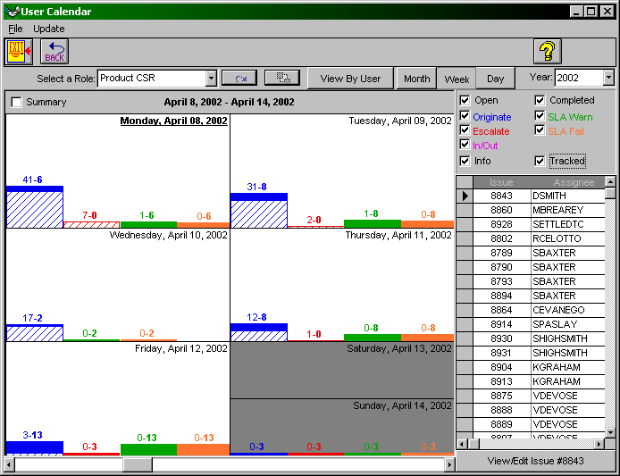
Instead of showing the individual events that occurred on each day, the system brings all the events for the call Originated on each day together on that day. In Tracked mode, we follow the history of the 47 issues that were Originated on April 8th. 7 of them eventually escalated, 7 of them Warned (one of which is completed) and 6 of them Failed (none of which are completed). If you can explain Tracked better, more power to you.

Switching to Summary mode:
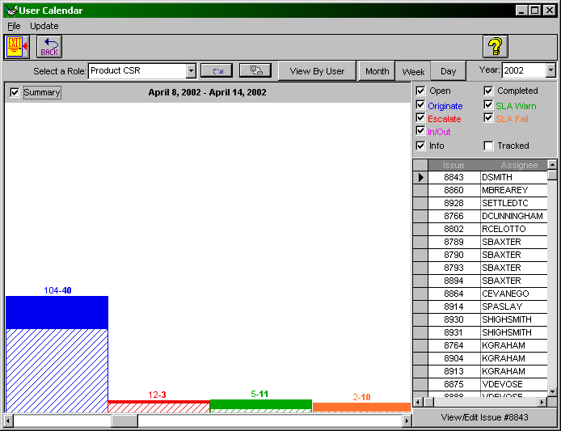
shows a graphical summary for the entire period of April 8th to April 14th. The summary grid behaves the same.

Double clicking the upper right corner of the grid (the little grey rectangle to the left of ‘Issue’, will expand the grid to full screen. This will enable the printing features.
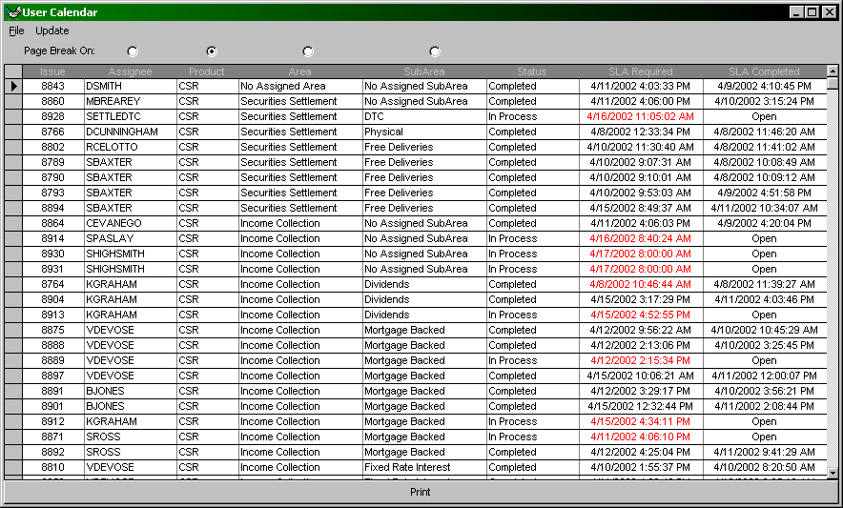
The large print button at the bottom of the screen will print the grid in its entirety just as it appears on the screen. Columns can be resized, and will be printed as such. The buttons above the Assignee, Product, Area, and SubArea columns define how the print out will be page-broken. If Assignee is selected, the printer will break for each Assignee. Likewise for the Product, Area, and SubArea.

The last function is the Update menu. This allows you to set the Calendar to automatically update itself every 1 or 5 minutes, or to turn off the updating. This allows you to keep the calendar up, and as time goes by, it will keep itself up to date with the changing times.

You can use the first screen shot again here for the color coding of the 5 main sections.

There are six main sections on the Calendar form:
- Which issues to display is controlled by the controls in the Yellow section
  - Open checkbox: display issues still open
  - Completed checkbox: display issues that are completed
  - View by User/Role
    - When Viewing by User:
      - The Select a User combo will be populated with a list of all the users in the database. This combo box is used to select the Active User.
      - The Members button is enabled when a workgroup is the Active User. This option selects all the members of the Active User workgroup.
      - If the Originator button is selected, display issues that have been originated by the Active User. If it is unselected, display issues that are currently assigned to the Active User.
    - When Viewing by Role:
      - The Select a Role combo will be populated with the Active User’s roles, as well as a hierarchical list of products, areas and sub-areas. This combo box is used to select the Active Role.
      - If the Active Role is a:
        - Product/Area/SubArea, display all issues currently in the Active Role.
        - User, display all issues currently originated or assigned to the Active Role, depending on the setting of the Originator button (see above)
        - Work Group, display all issues currently originated or assigned to the Active Role, depending on the setting of the Originator button, or originated or assigned to members of the Active Role, depending on the setting of the Members button.
- Which events to display is controlled by controls in the Green section
  - Originate: show when issue originated
  - Escalate: show when/if issue will be/was escalated
  - SLA Warn: show when SLA failure warning will be/was issued
  - SLA Fail: show when SLA failure will occur/occurred
  - In/Out: If Viewing by User, the show when Active User was in / out
- Which date range to display is controlled by controls in the Red Section
  - Year combo: selects the year
  - Period buttons: selects what period to show (Month, week, day)
  - Scroll bar: scroll through the selected year by the selected period. The scroll bar represents the entire year, so all the way to the left is January, all the way to the right is December.
- Event management is controlled by controls in the Purple Section
  - The Info check box:
  - Unchecked, the individual issue numbers are displayed in the date boxes. Bold numbers are issues that are still open. Plain numbers are issues that are completed.
    - When an issue number is clicked, that issue is now the Active Issue
      - A summary of the issue will appear in the Summary Area. Double clicking the Summary Area will expand the summary to full screen. Double clicking the expanded summary will return to the calendar view.
      - Clicking the View/Edit button will bring up the Issue Function form with the Active Issue
  - Checked, a chart summarizing the count of the events is displayed in the date boxes
    - When the Info box is checked, the Summary check box appears. When the Summary box checked, all dates in the Date Range are summarized into one chart.
    - In the Summary Area a grid will appear listing all the issues that are summarized. Double clicking this grid will expand it to the full screen and allow sorting and printing. Double clicking the expanded grid will return to the calendar view.
  - The Track check box is available only when the Info box is checked:
  - If the Track box is unchecked, the events for any given issue will be summarized on the date of the individual event
  - If the Track box is checked, all the events for any given issue will be summarized on the date which the issue originated.
- Summary info is in the Blue Section
  - This will display a summary of the Active Issue when the Info box is unchecked, and a grid listing the all the issues that are summarized when the Info box is checked. Double clicking this grid will expand it to the full screen and allow sorting and printing. Double clicking the expanded grid will return to the calendar view.
- Main calendar display
  - Holidays appear in light pink, today’s date in light tan. Currrent Date is bold and underlined.
  - The contents of the Main calendar display are explained above.

